

**Tribhuvan University**

**Faculty of Humanities and Social Sciences**

Software Project Management

A LAB REPORT

Submitted to

Department of Computer Application

Shahid Smarak College

*In partial fulfillment of the requirements for the Bachelors in Computer Application*

**Submitted by: -**

Amir Maharjan

**Internal supervisor**

Sushant Maharjan

**External Supervisor**

**Table of Contents**

**Question 1 1**

**Question 2 3**

**Question 3 5**

**Question 4 6**

**Question 5 9**

**Question 6 11**

**Question 7 13**

**Question 8 15**

**Question 9 17**

**Question 10 19**

**Question 11 21**

**Question 12 23**

# 

# Question 1

Draw a precedence network diagram by performing forward and backward passes. Also determine the critical path and completion date of the project. (Use the information given in the table).

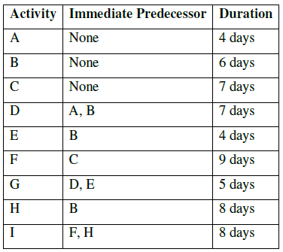

**Gantt Chart**

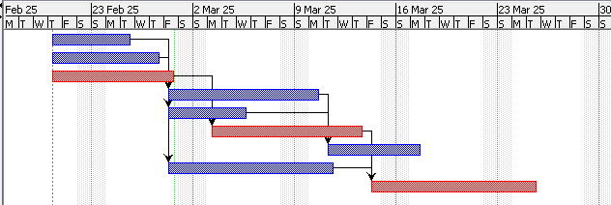

**Information**

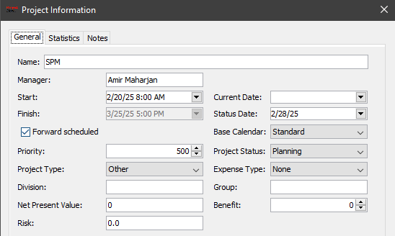

**Network Diagram**

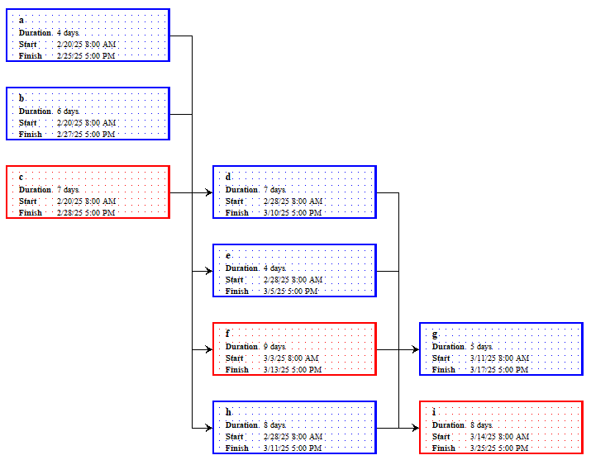

**Forward Pass**

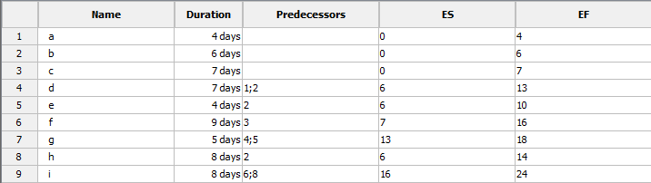

**Backward Pass**

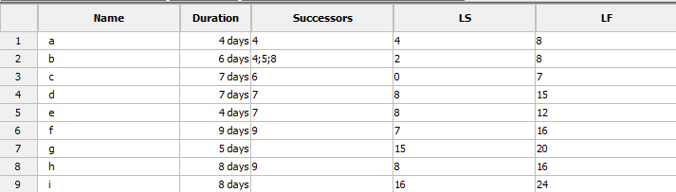

# Question 2

Draw a precedence network diagram by performing forward and backward passes. Also determine the critical path and completion date of the project. (Use the information given in the table)

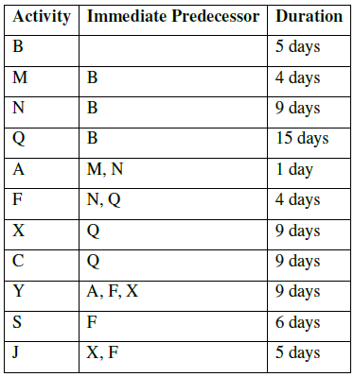

**Gantt Chart**

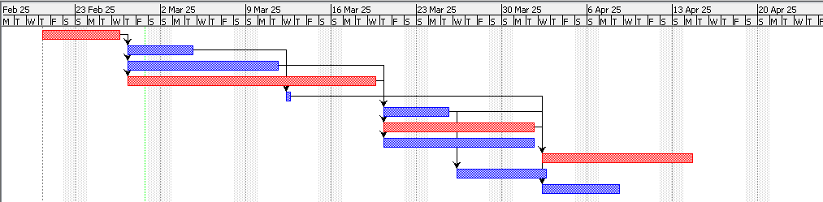

**Information**

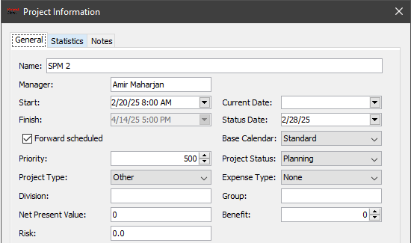

**Network Diagram**

29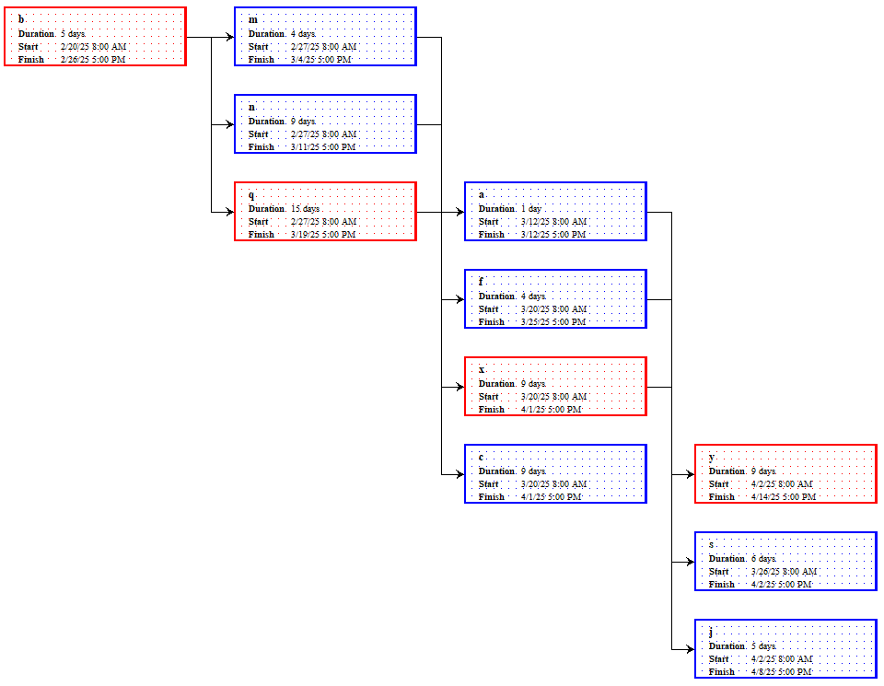

**Forward pass**

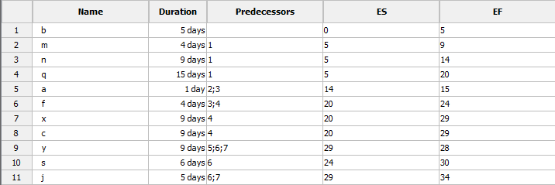

**Backward Pass**

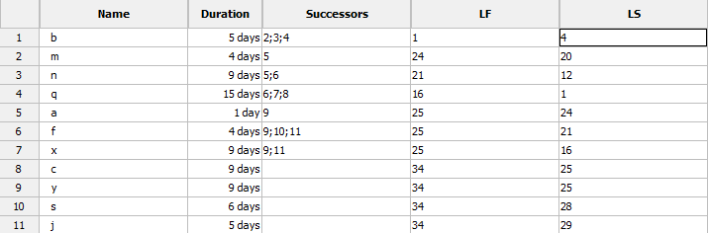

# Question 3

Draw a precedence network diagram by performing forward and backward passes. Also determine the critical path and completion date of the project. (Use the information given in the table).

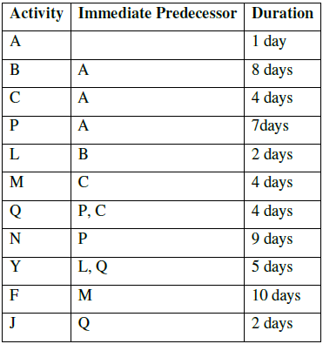

**Gantt Chart**

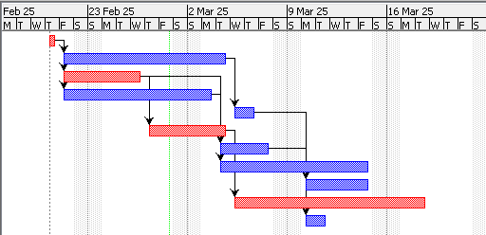

**Information**

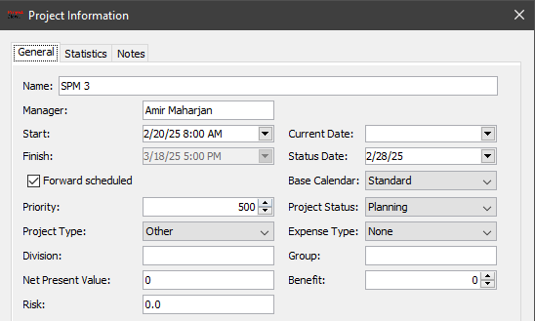

**Network Diagram**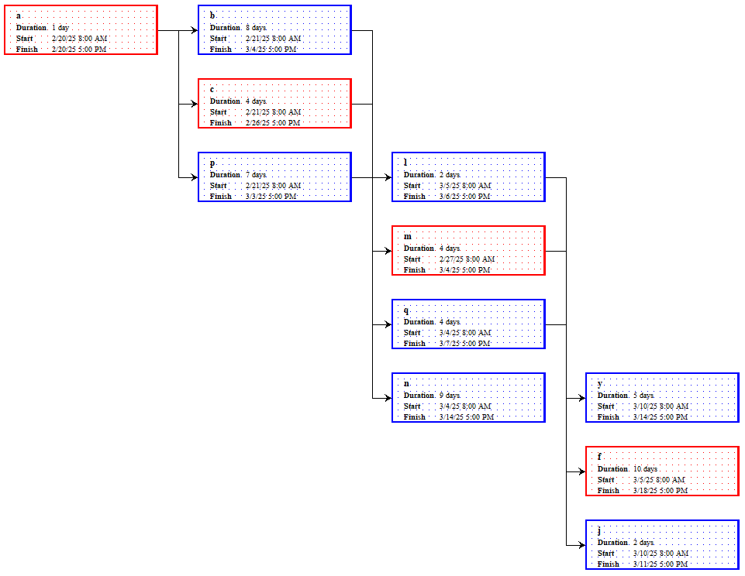

**Forward Pass**

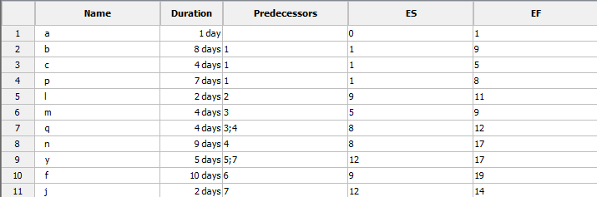

**Backward Pass**

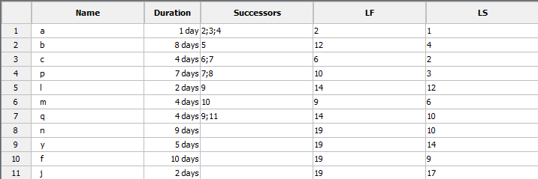

# Question 4

Draw a precedence network diagram by performing forward and backward passes. Also determine the critical path and completion date of the project. (Use the information given in the table).

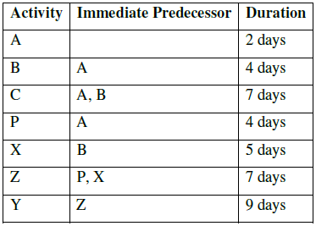

**Gantt Chart**

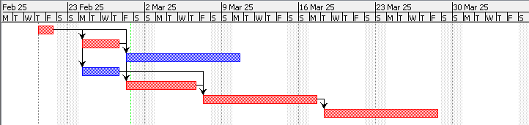

**Information**

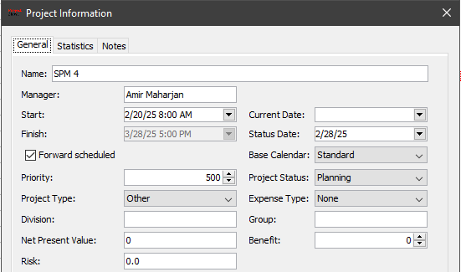

**Network Diagram**

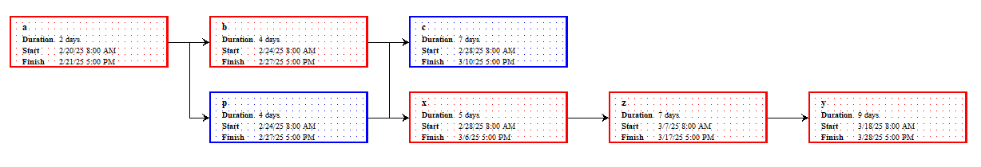

**Forward Pass**

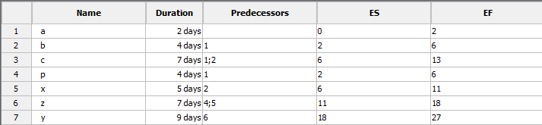

**Backward Pass**

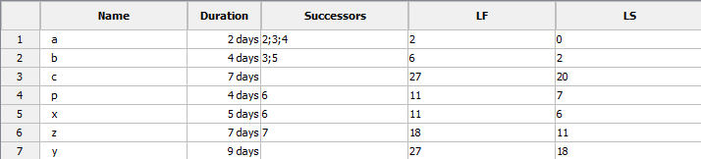

# Question 5

Consider the following table of information:

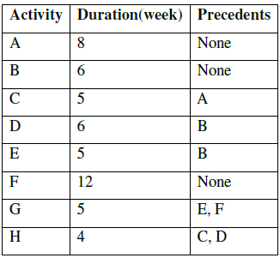

Draw the precedence network diagram and Gantt Chart.

**Gantt Chart**

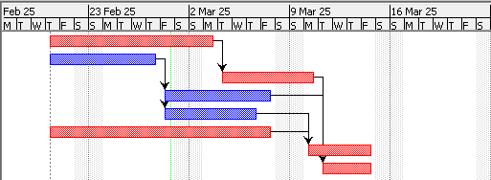

**Information**

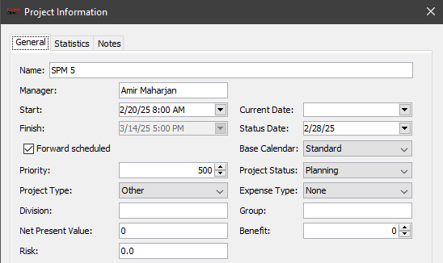

**Network Diagram**

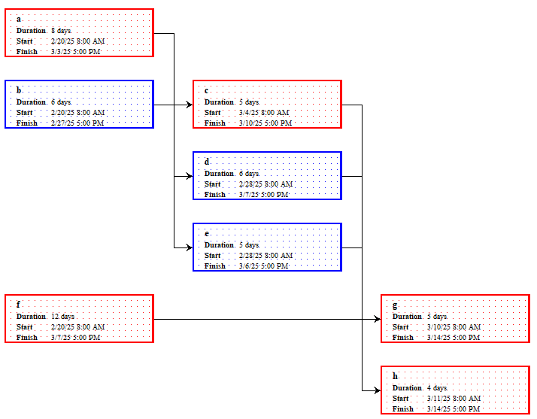

**Forward Pass**

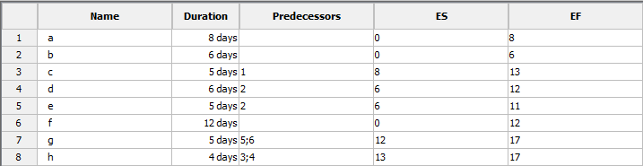

**Backward Pass**

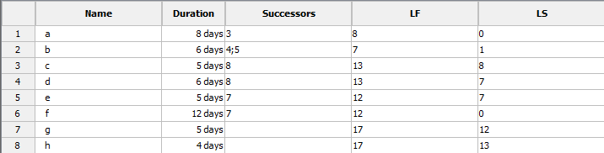

# Question 6

Consider the following table of information:

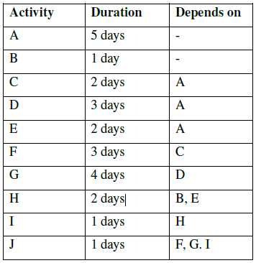

Draw the precedence network diagram and Gantt Chart.

**Gantt Chart**

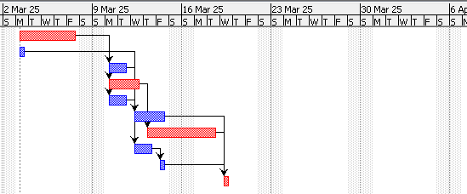

**Information**



**Network Diagram**

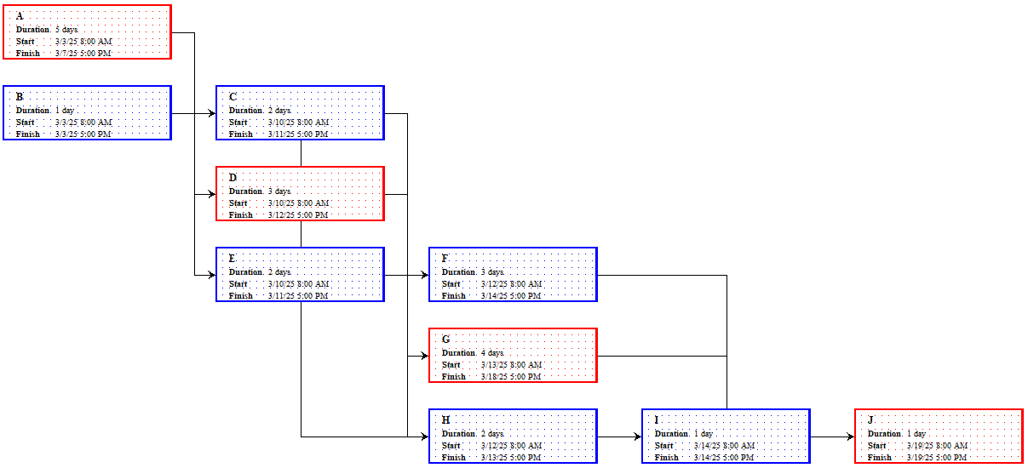

**Forward Pass**

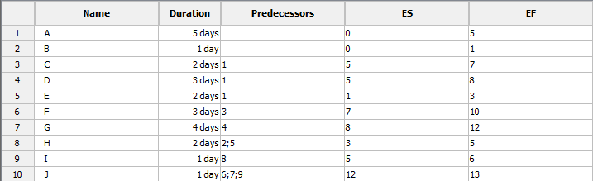

**Backward Pass**

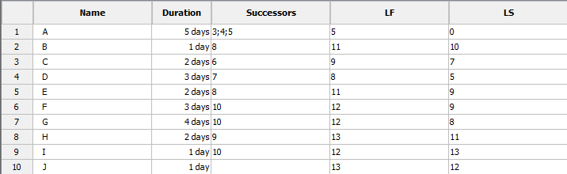

# Question 7

Consider the following table of information:

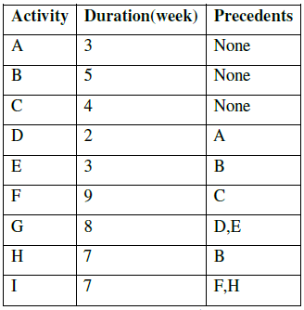

Draw the precedence network diagram and Gantt Chart.

**Gantt Chart**

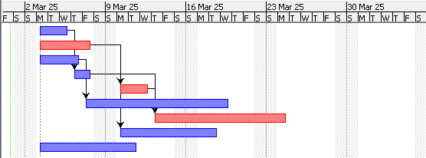

**Information**

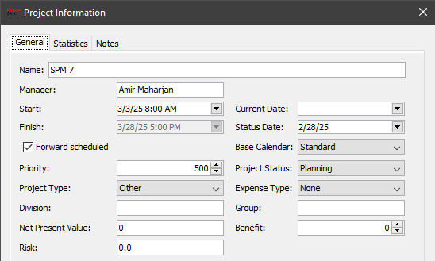

**Network Diagram**

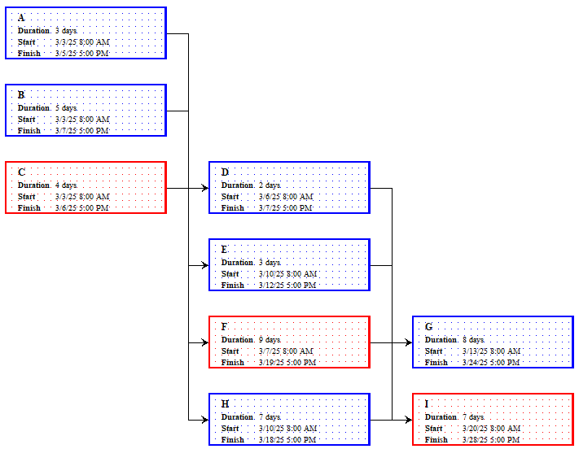

**Forward Pass**

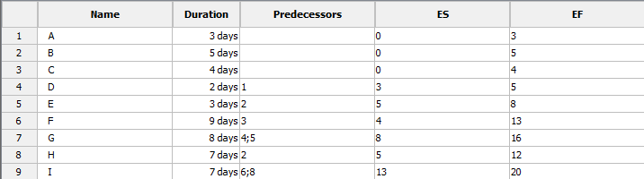

**Backward Pass**

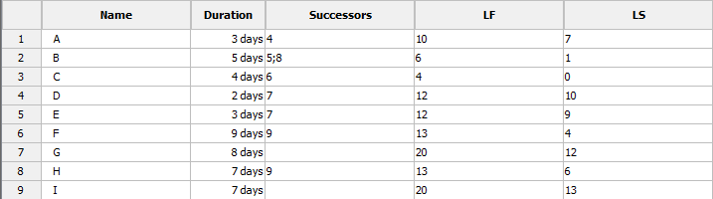

# Question 8

Consider the following table of information:

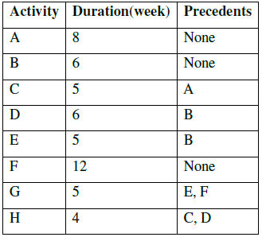

Draw the precedence network diagram and Gantt Chart.

**Gantt Chart**

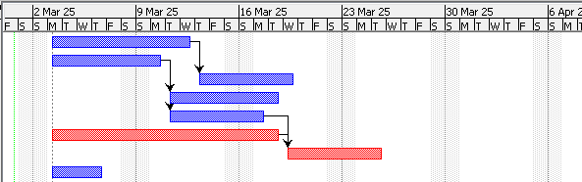

**Information**

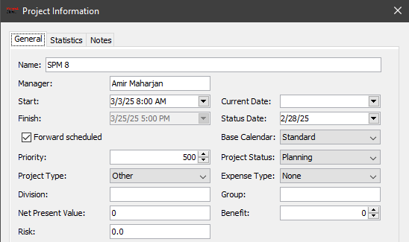

**Network Diagram**

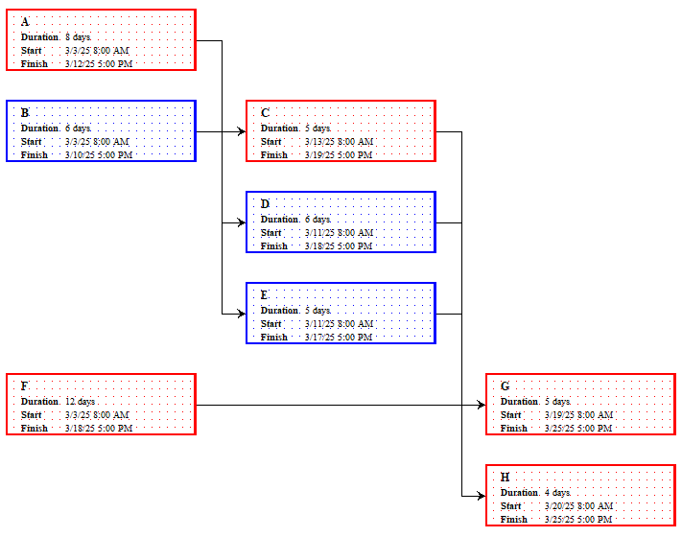

**Forward Pass**

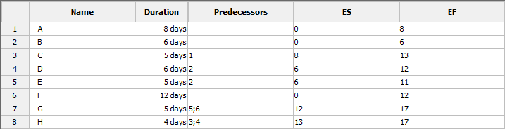

**Backward Pass**

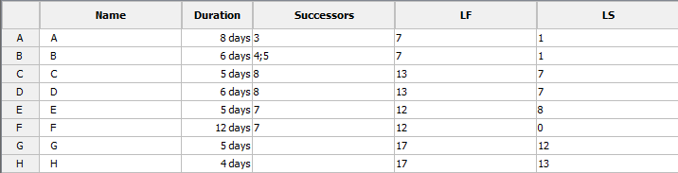

# Question 9

Consider the following table of information:

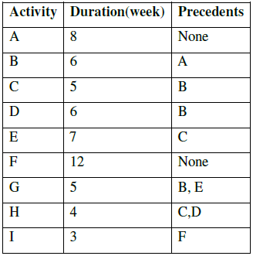

Draw the precedence network diagram and Gantt Chart.

**Gantt Chart**

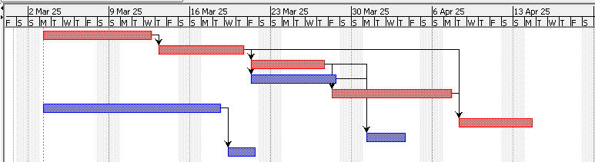

**Information**

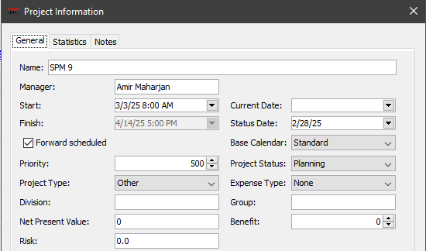

**Network Diagram**

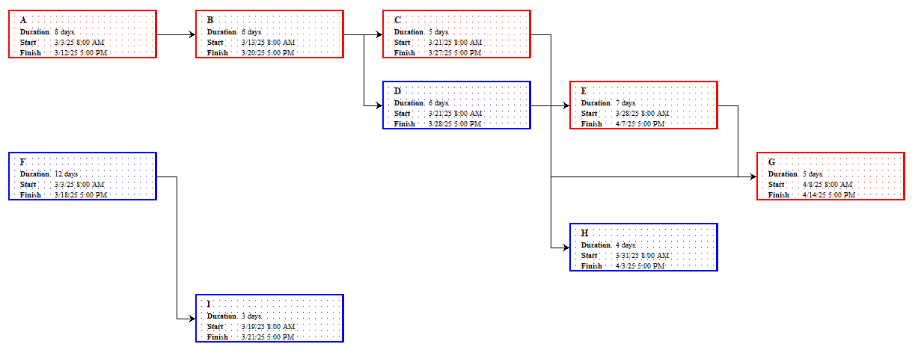

**Forward Pass**

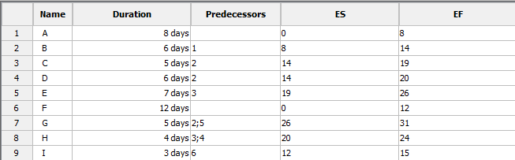

**Backward Pass**

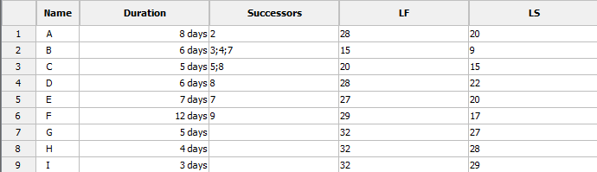

# Question 10

Consider the following table of information:

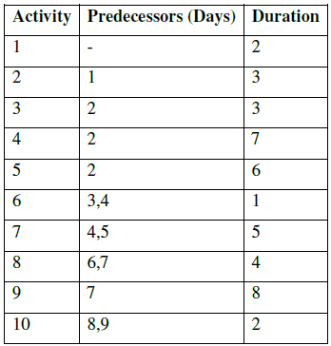

Draw the precedence network diagram and Gantt Chart.

**Gantt Chart**

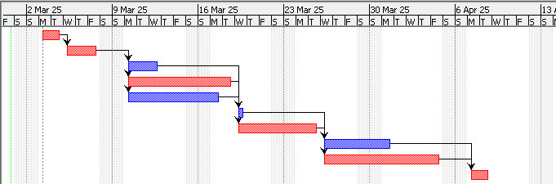

**Information**

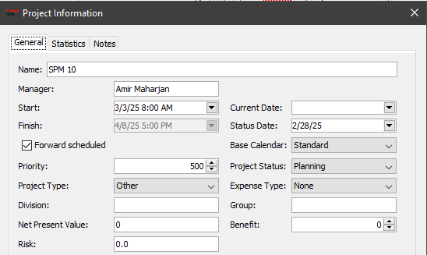

**Network Diagram**

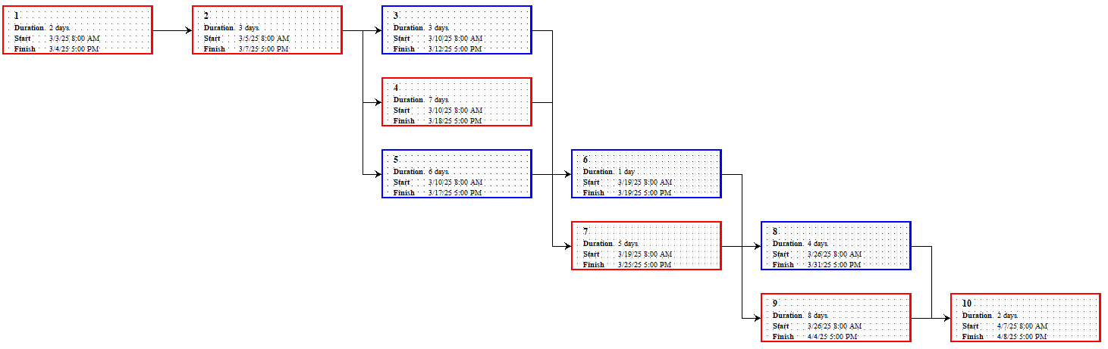

**Forward Pass**

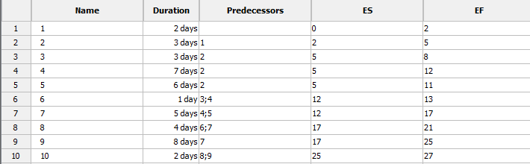

**Backward Pass**

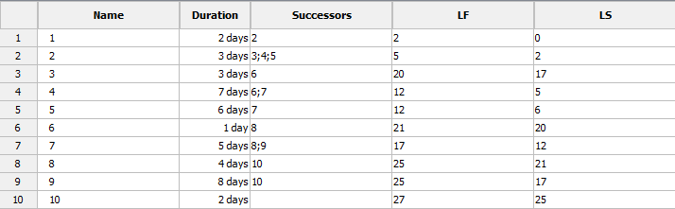

# Question 11

Consider the following table of information:

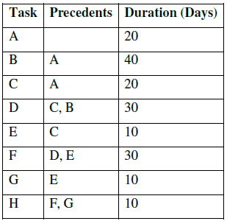

Draw the precedence network diagram and Gantt Chart.

**Gantt Chart**

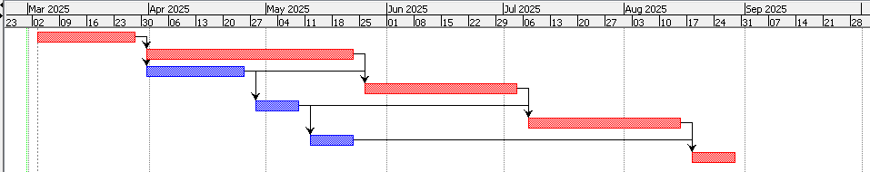

**Information**

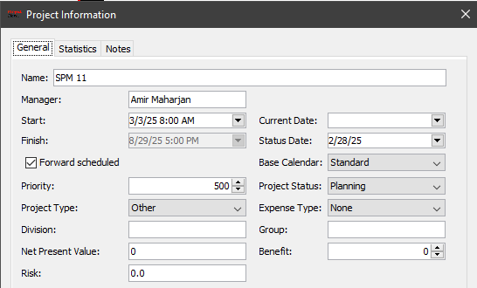

**Network Diagram**

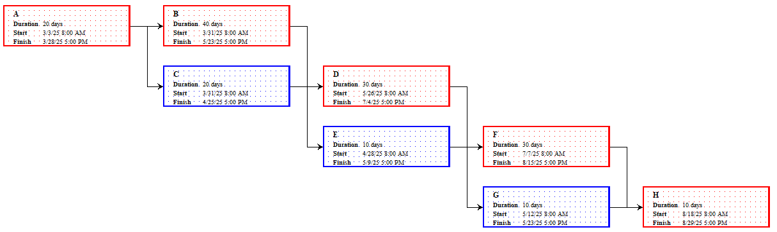

**Forward Pass**

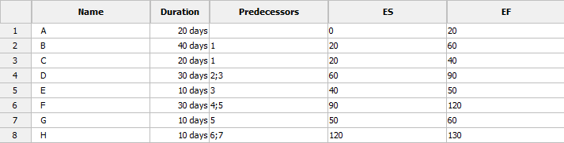

**Backward Pass**

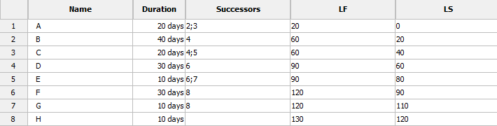

# Question 12

Consider the following table of information:

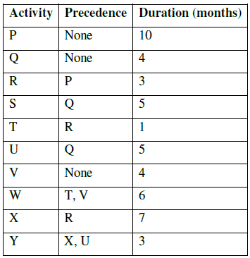

Draw the precedence network diagram and Gantt Chart.

**Gantt Chart**

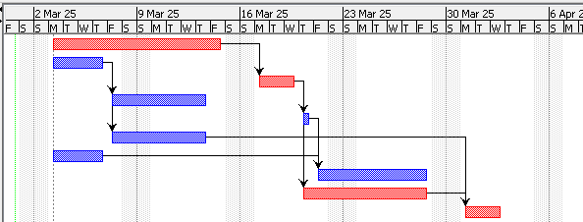

**Information**

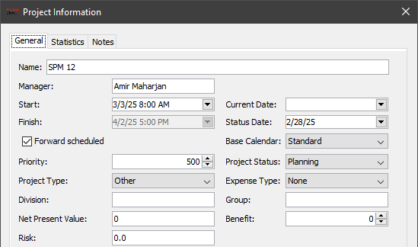

**Network Diagram**

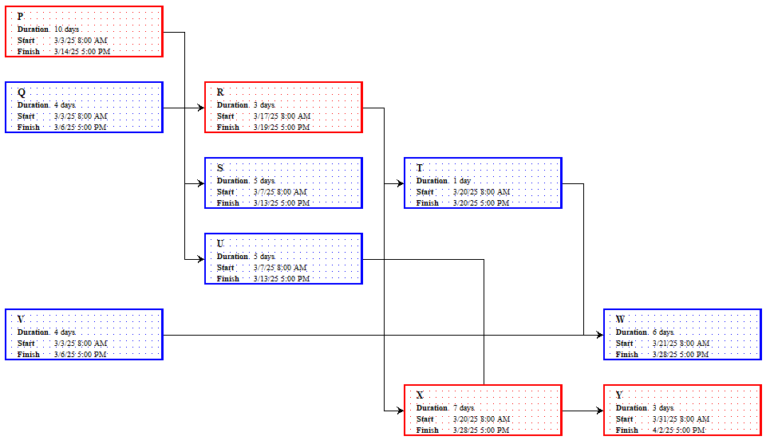

**Forward Pass**

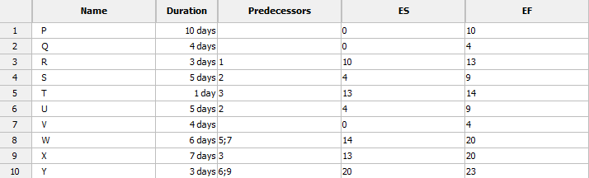

**Backward Pass**

